**OUTPUT of our Project:**

**Group Members**

Sahil, Nabiha, Momina, Awais

1. **Home Page (for all users(Applicants, Recruiters))**

**Output:**  
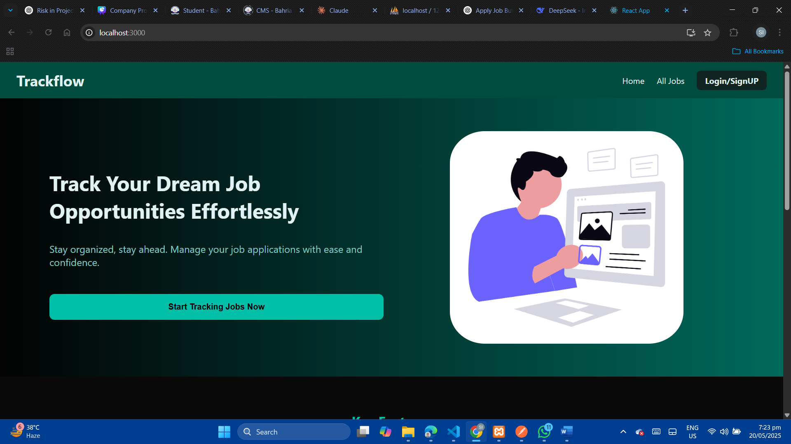  
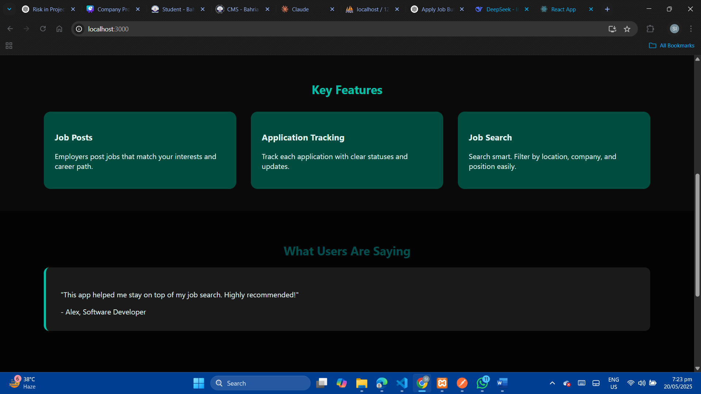  
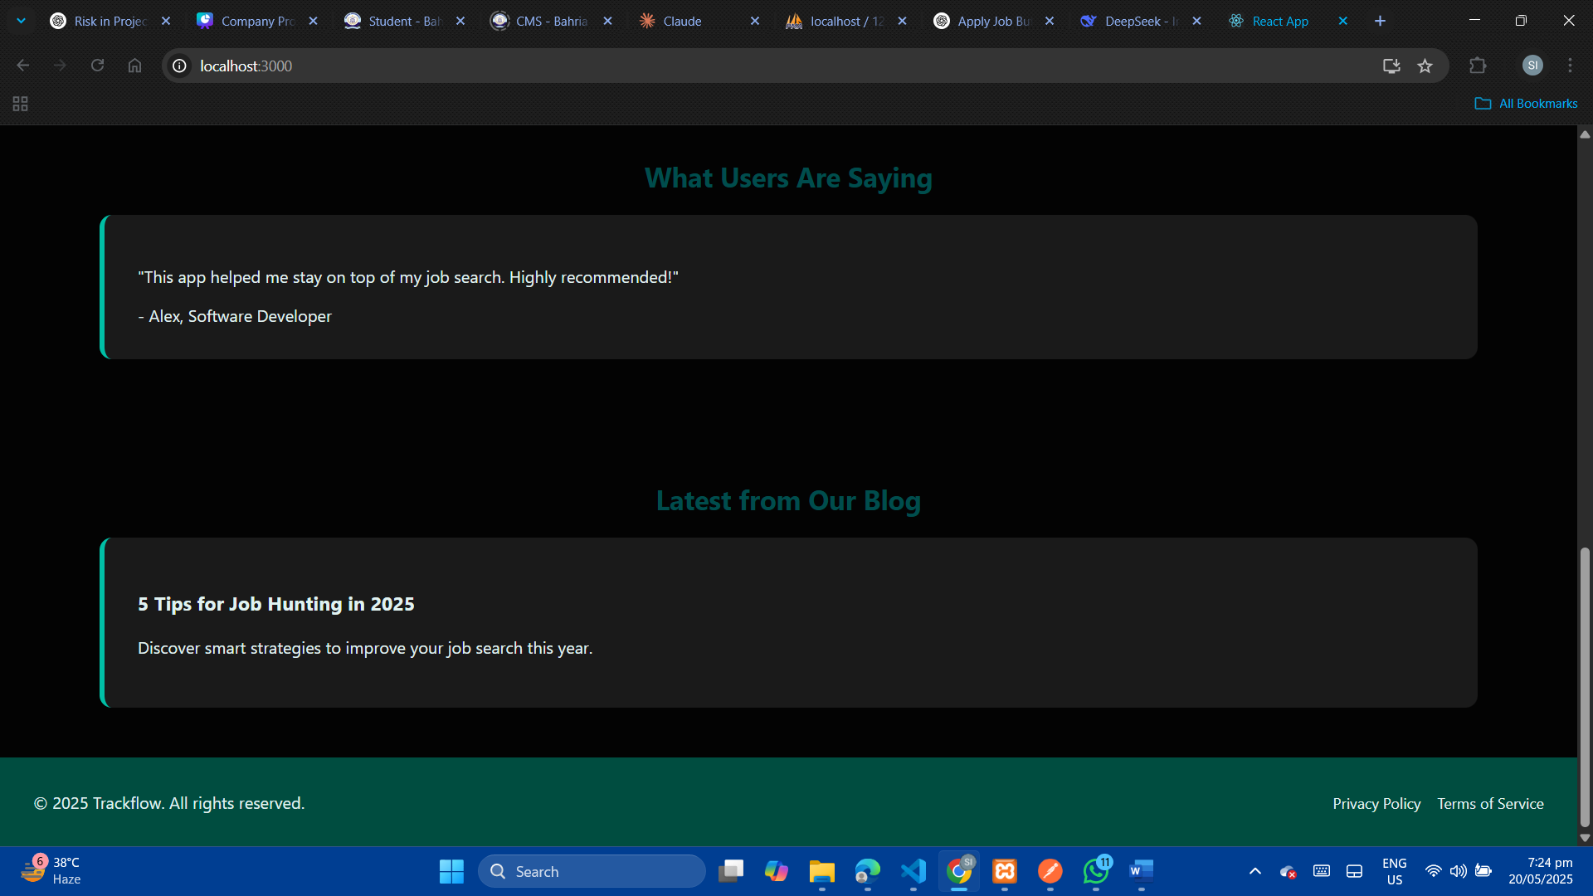

**2. User can signup/login and specify role**

**SignUp:**  
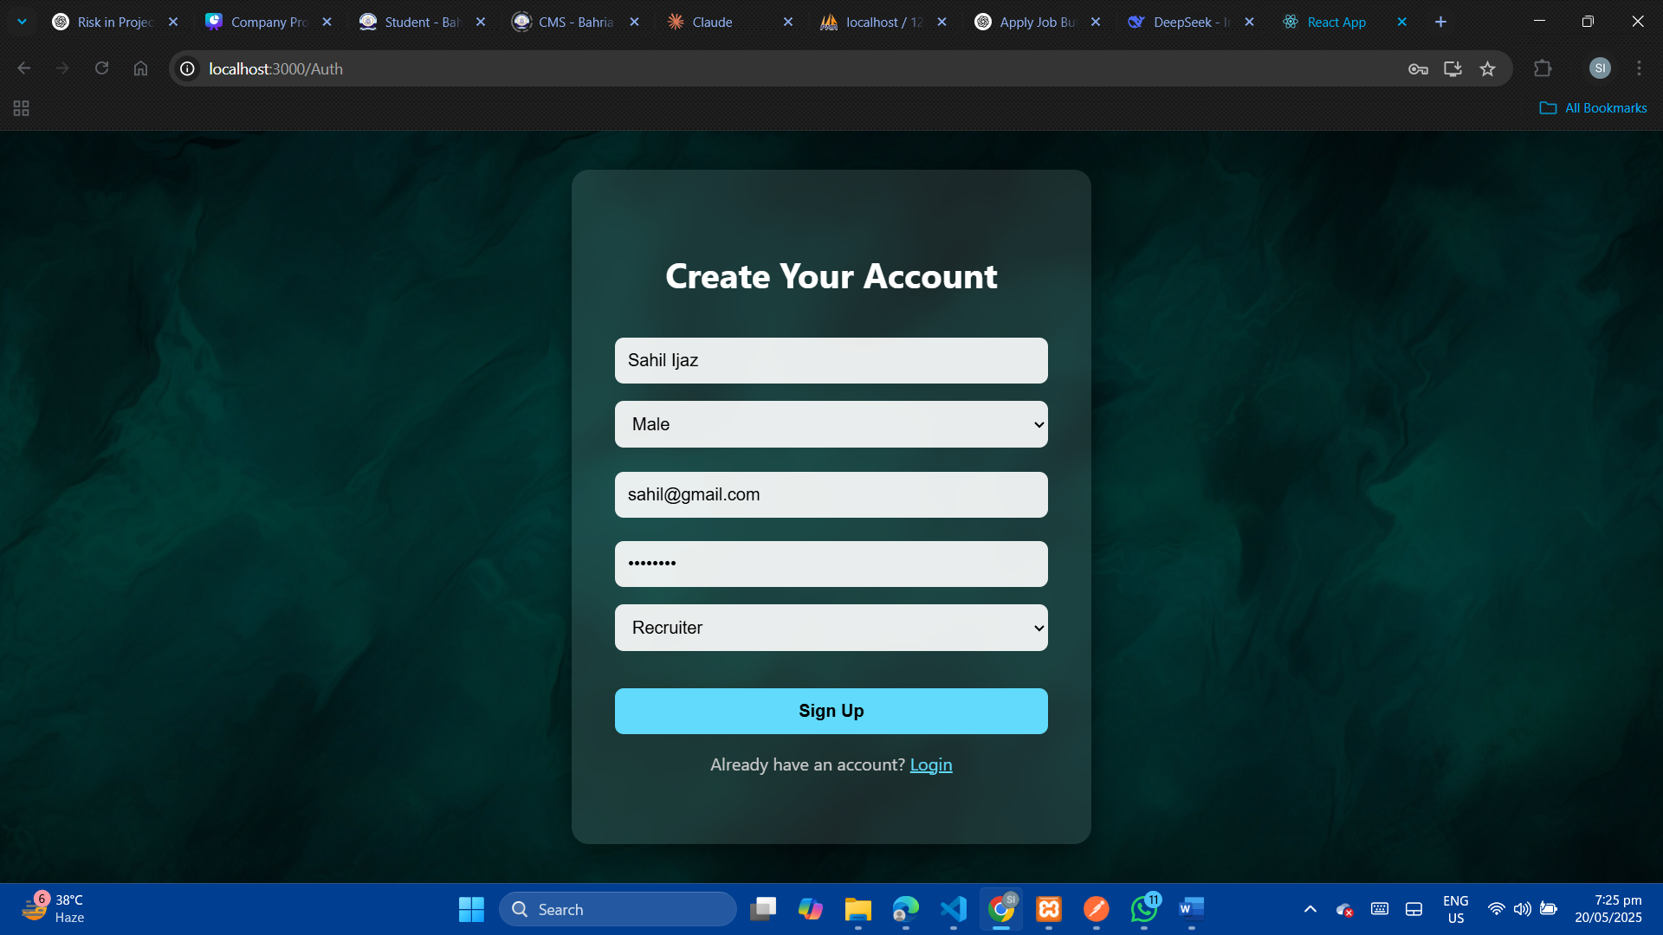

**LogIn:**   
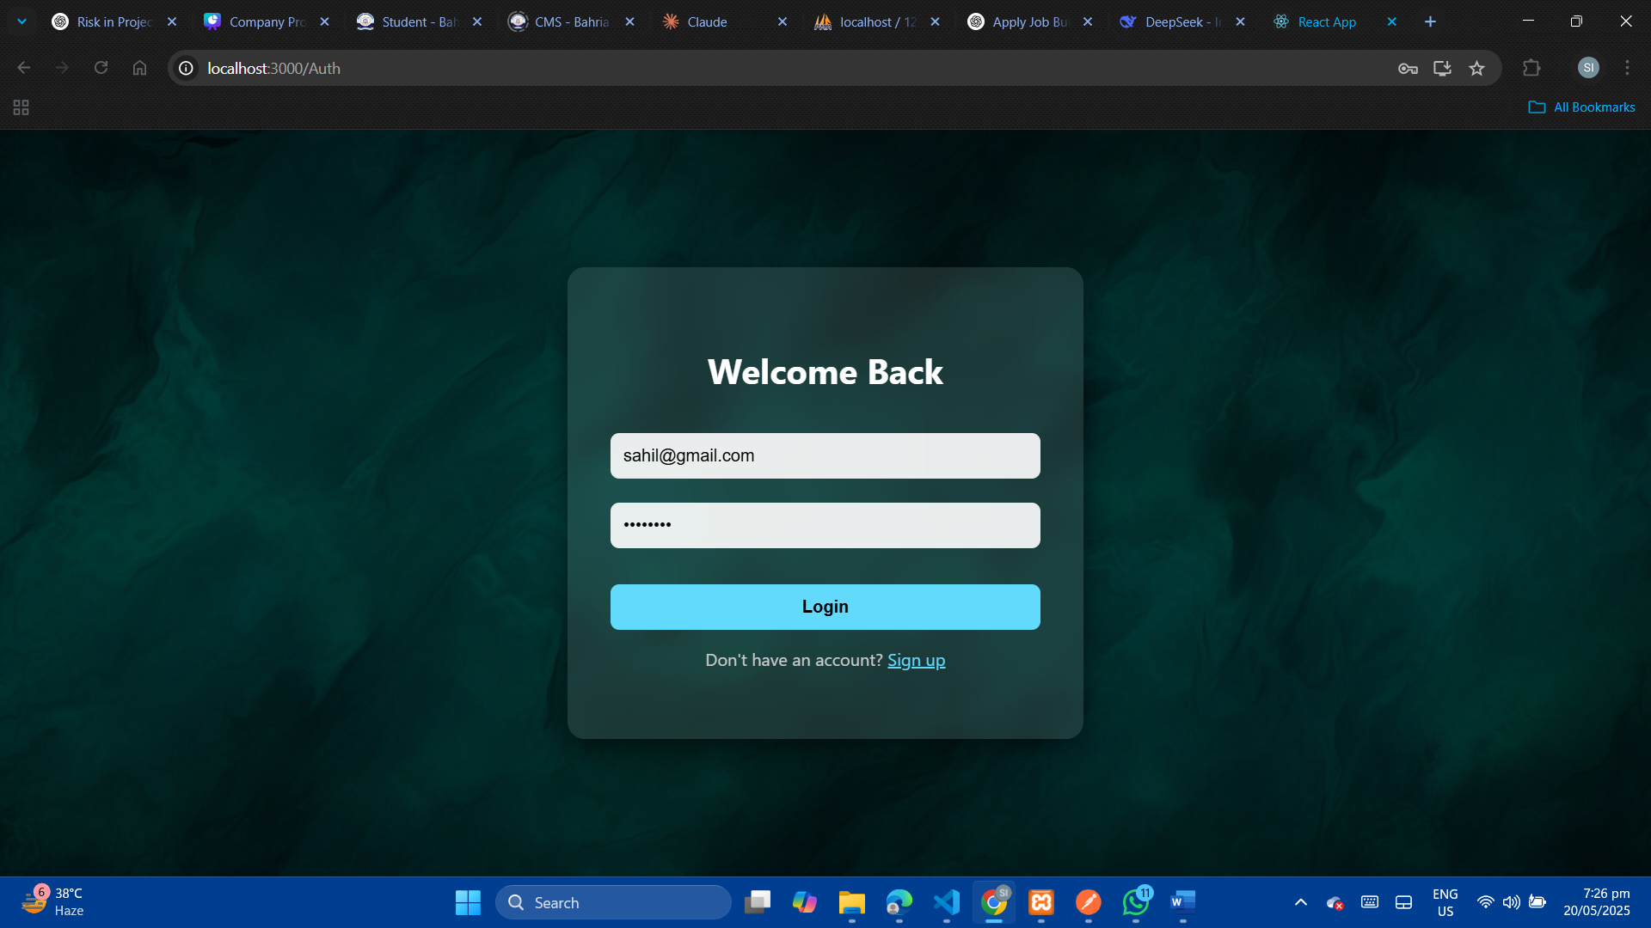

**3. Here, User can view all jobs posted by recruiters from all job tab in Nabar.  
Output:**  
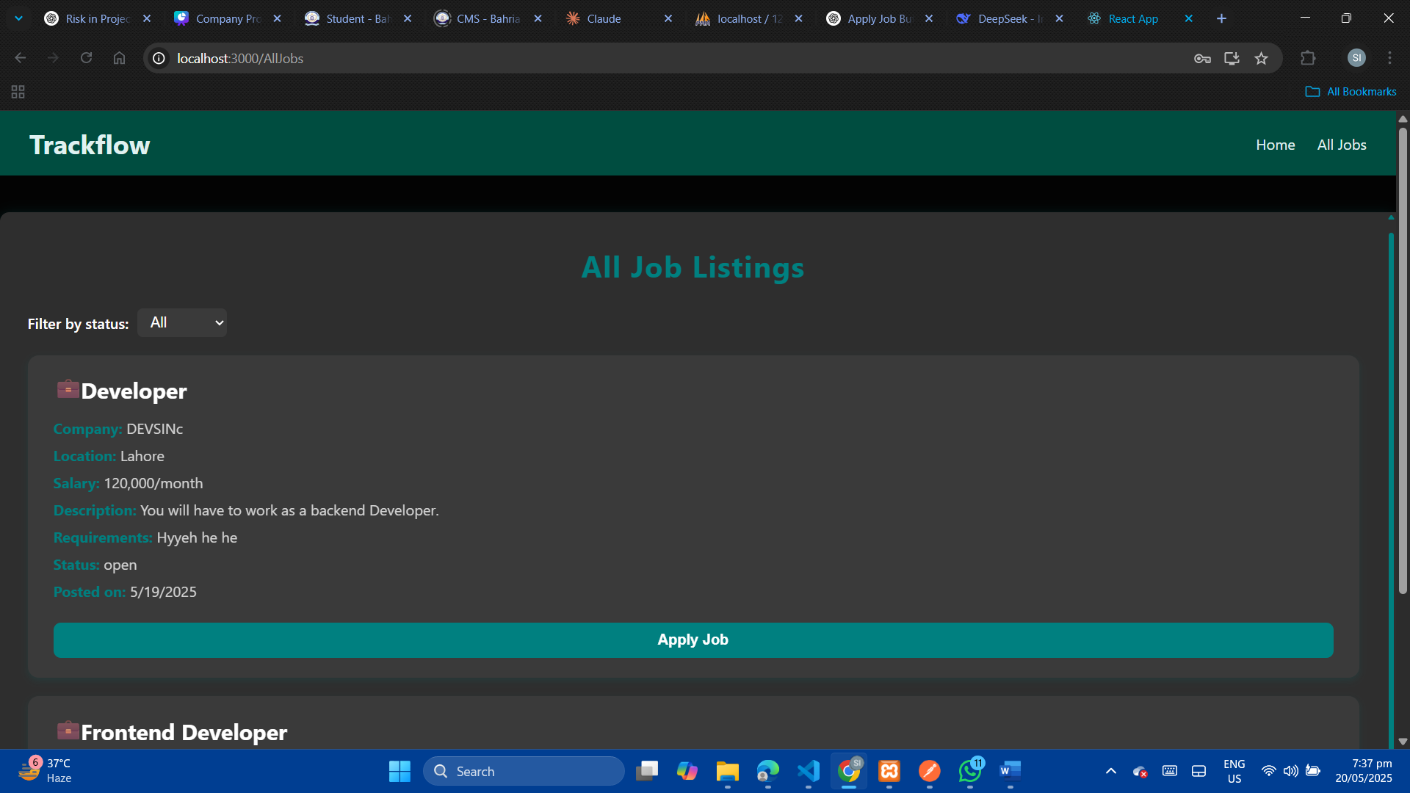

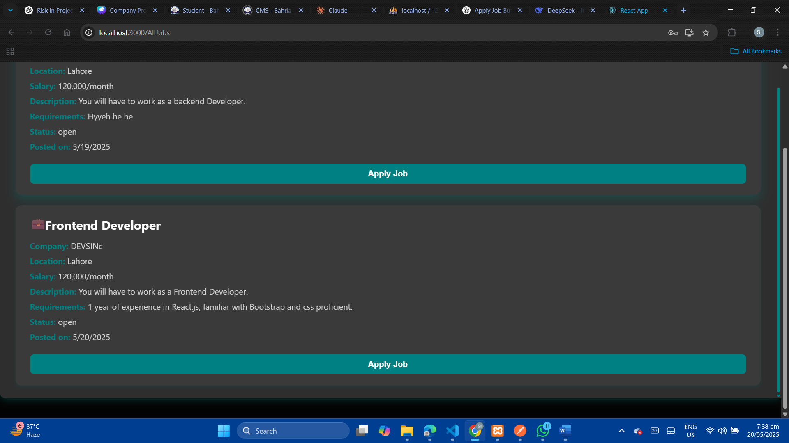

**4. User can Apply for job  
Output:**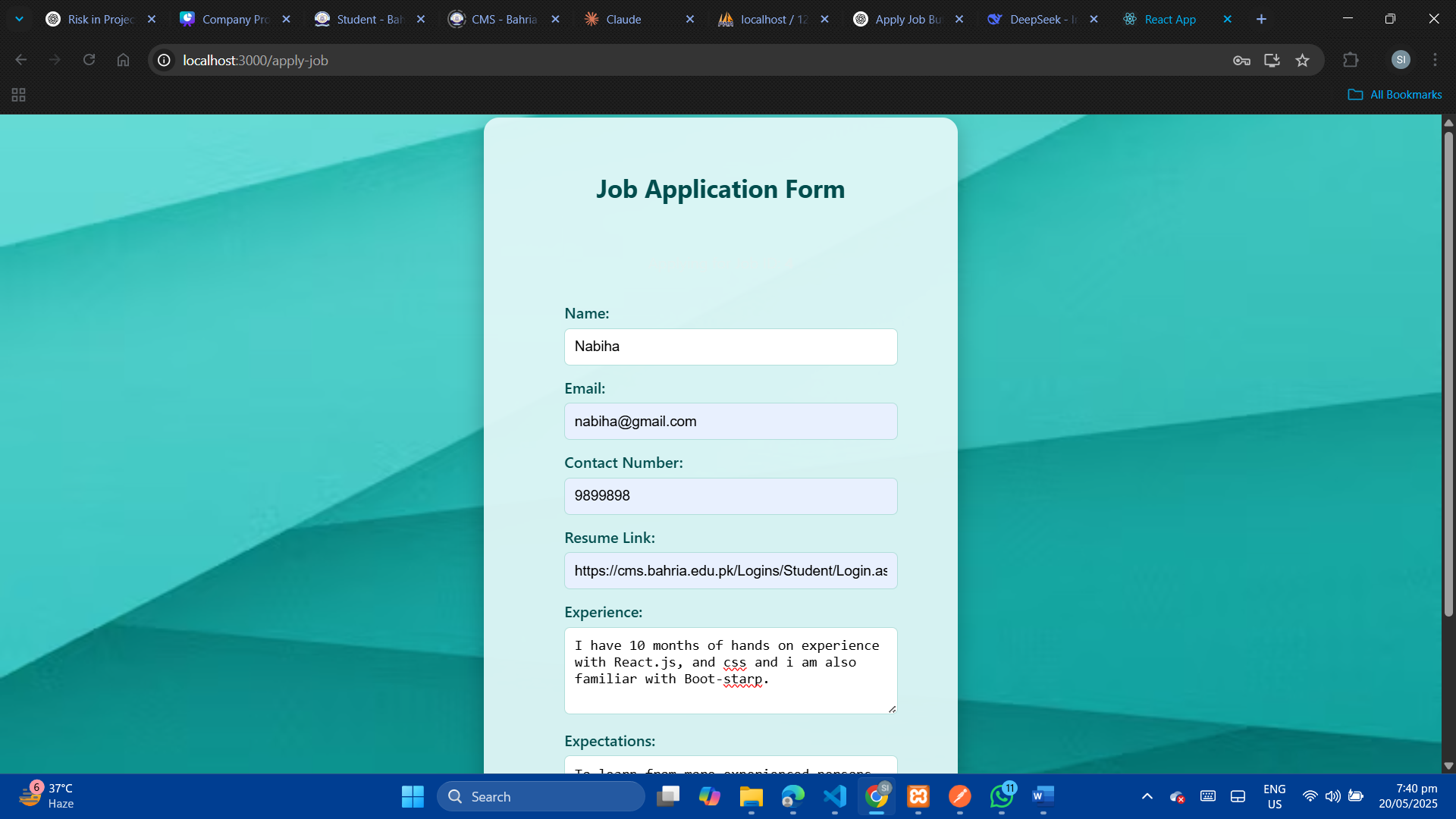  
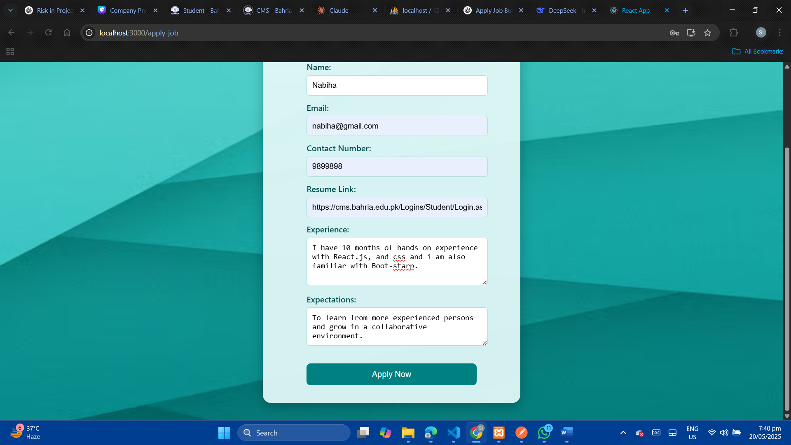

**5. User dashboard, here user can view job in which she/he applied.  
Output:**   
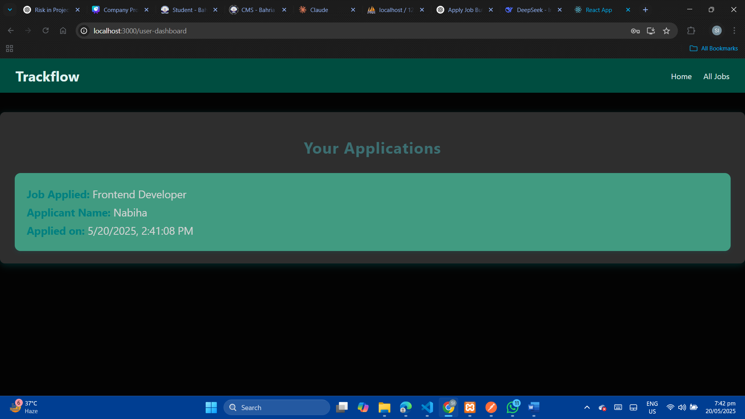

**6. Recruiter Dashboard, here recruiter can edit and delete jobs and post them too.  
Output:**   
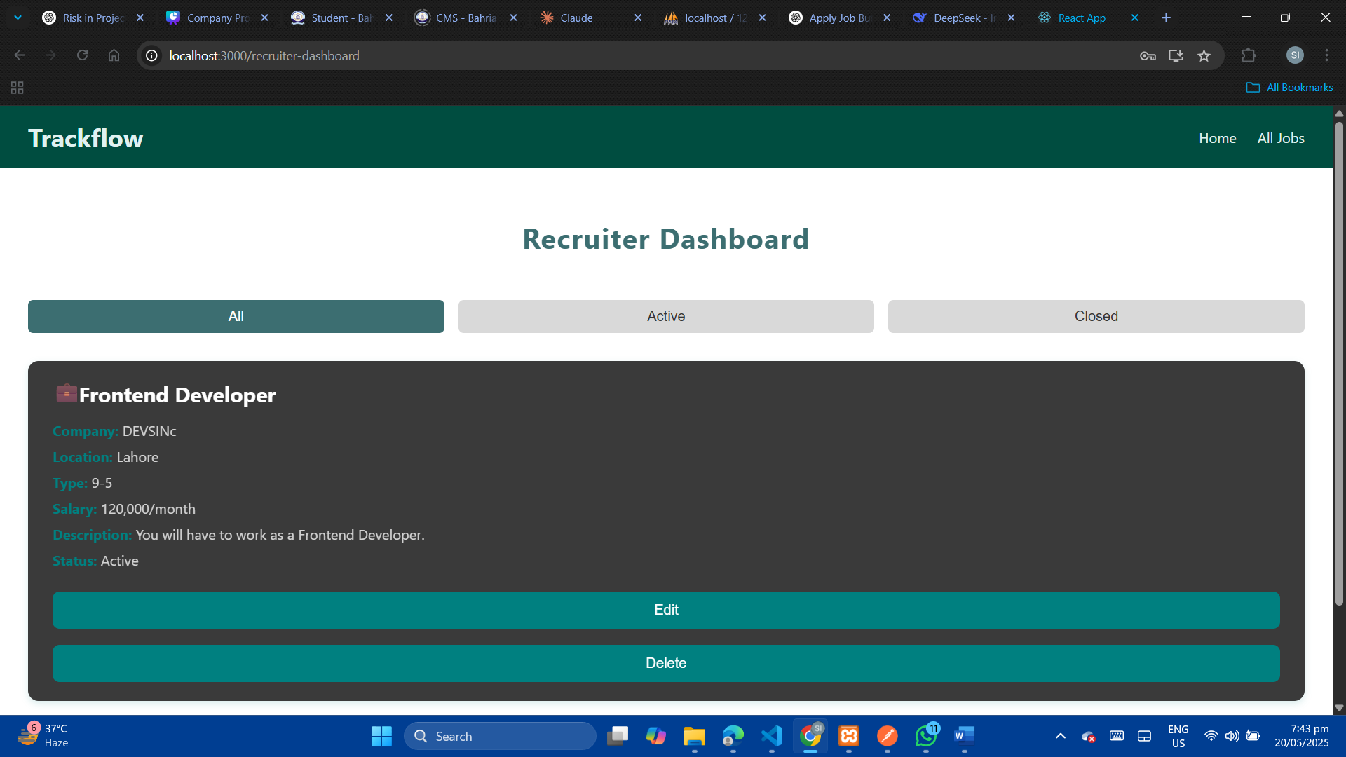

**Job being updated by recruiter :**

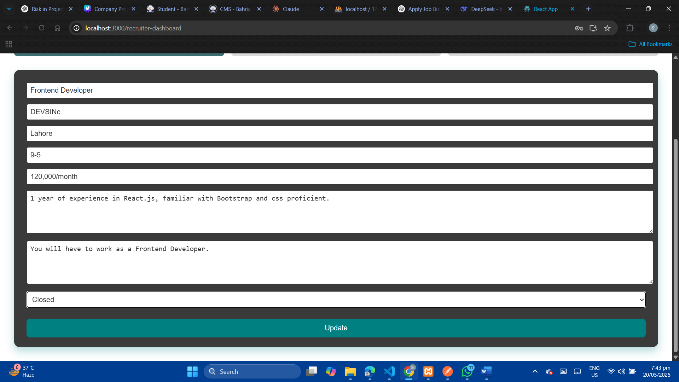

**Recruiter can create job that will be listed in all jobs!  
Output:**   
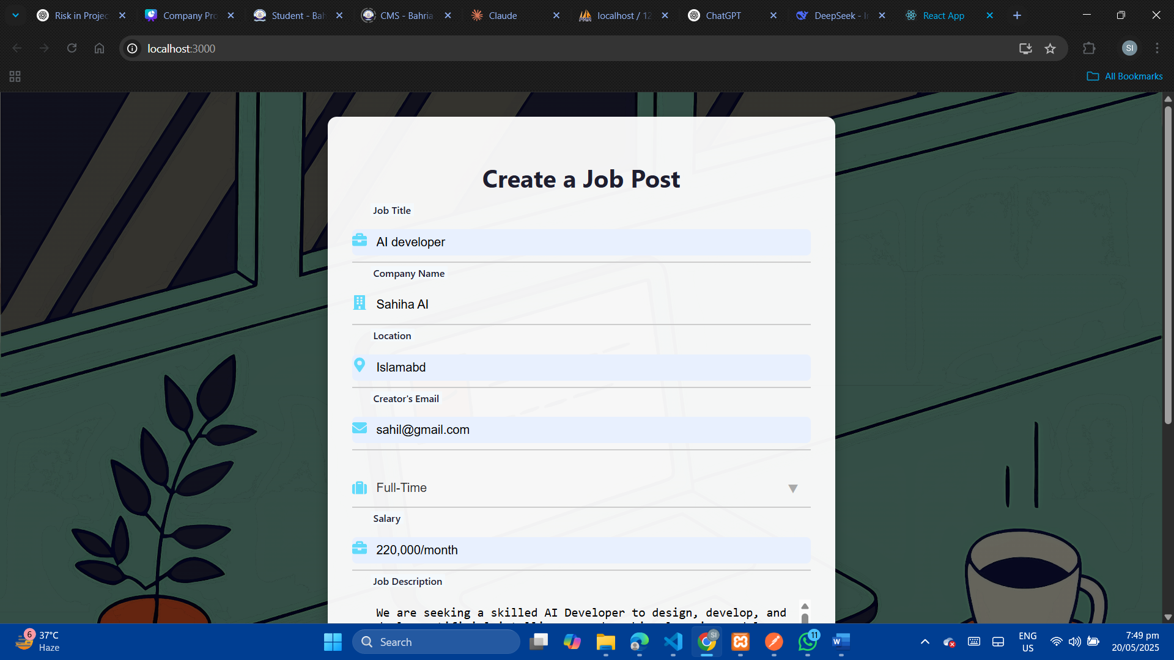

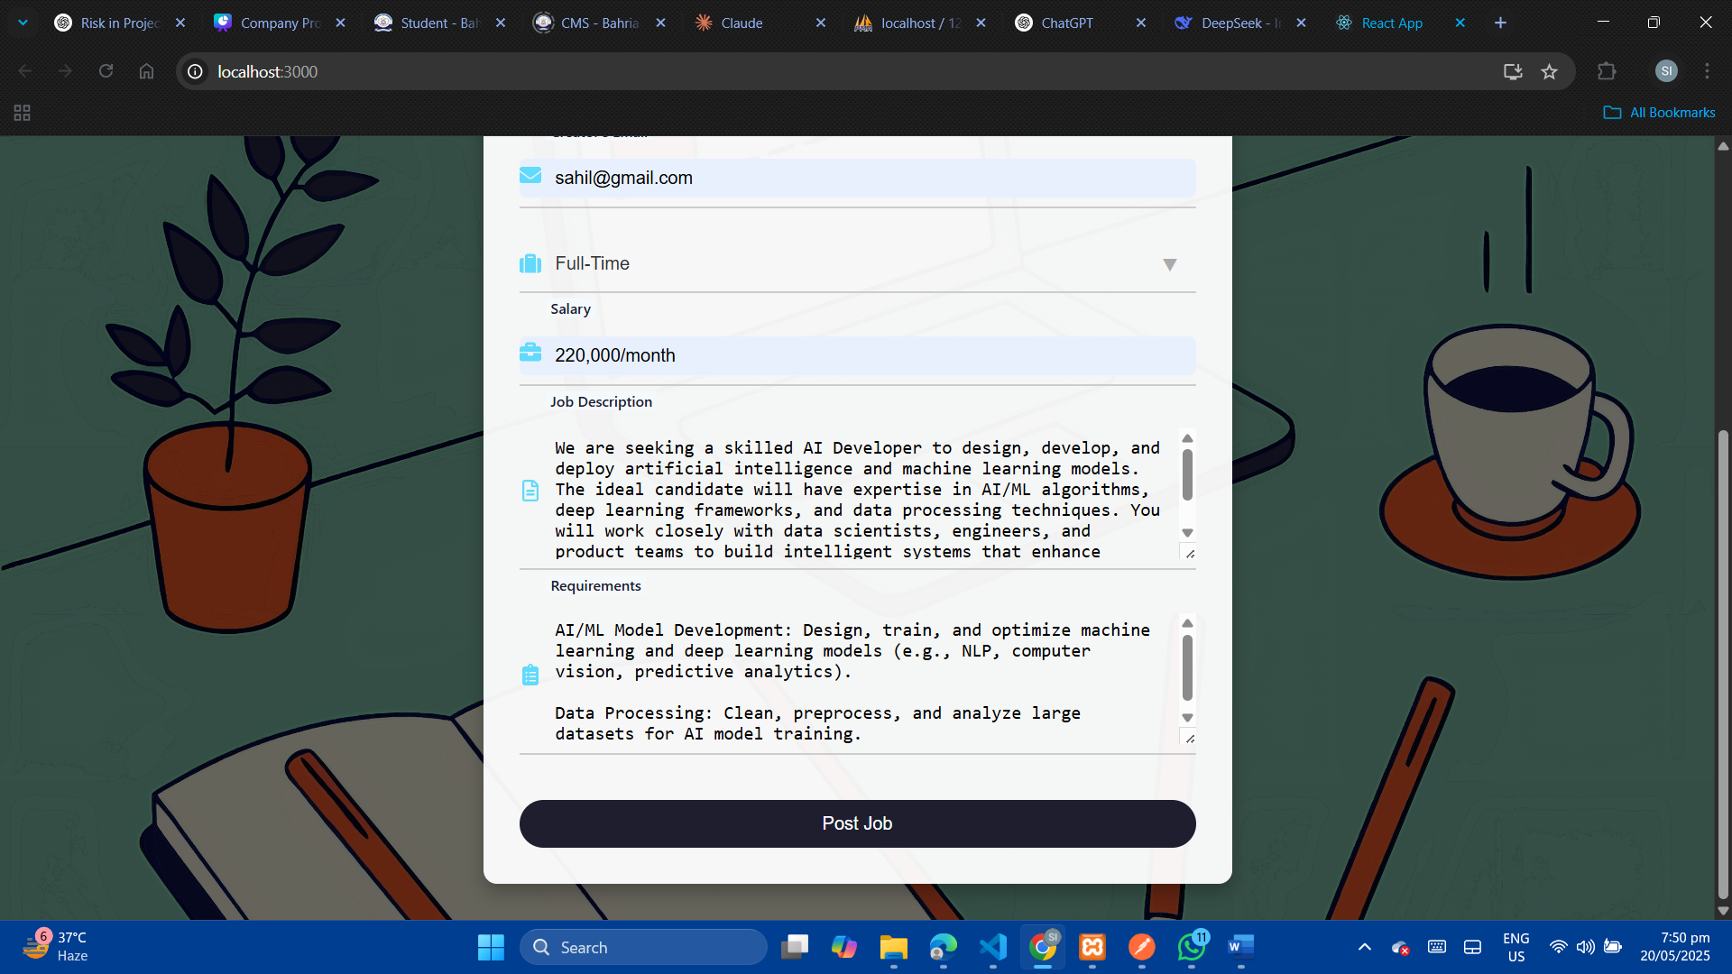

**Currently added job:**   
  
  
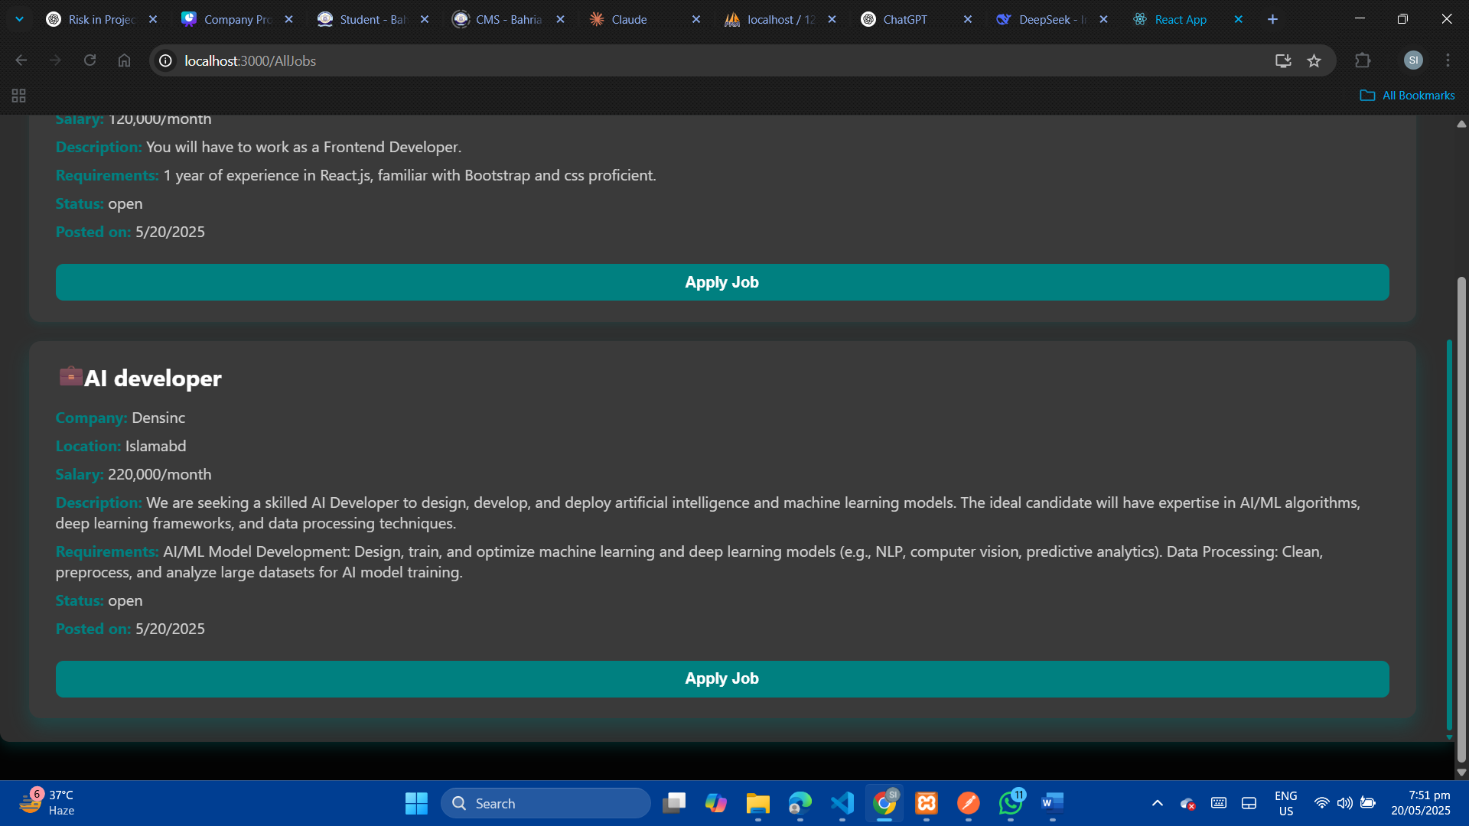

**Database:**   
  
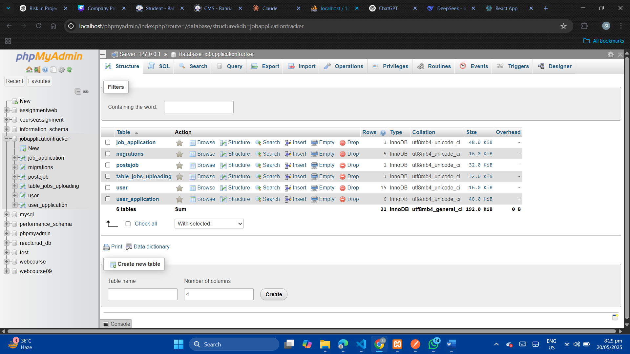

**Postman:**   
